1. **Create a database named library and a table named books with the following columns:**

* **id (INT, Primary Key, Auto Increment)**
* **title (VARCHAR(255))**
* **author (VARCHAR(100))**
* **year (YEAR)**

genre (VARCHAR(100))

create database library;

use library;

CREATE TABLE books(

id INT Primary Key Auto_Increment,

title VARCHAR(255),

author VARCHAR(100),

year YEAR,

genre VARCHAR(100)

);

1. **Insert the following book records into the books table:**

* **"The Great Gatsby", "F. Scott Fitzgerald", 1925, "Fiction"**
* **"Pride and Prejudice", "Jane Austen", 1813, "Romance"**
* **"To Kill a Mockingbird", "Harper Lee", 1960, "Fiction"**
* **"1984", "George Orwell", 1949, "Dystopian"**
* **"Moby Dick", "Herman Melville", 1851, "Adventure**"

INSERT INTO books (id, title, author, year, genre)

VALUES

(1, "The Great Gatsby", "F. Scott Fitzgerald", 1925, "Fiction"),

(2, "Pride and Prejudice", "Jane Austen", 1913, "Romance"),

(3, "To Kill a Mockingbird", "Harper Lee", 1960, "Fiction"),

(4, "1984", "George Orwell", 1949, "Dystopian"),

(5, "Moby Dick", "Herman Melville", 1951, "Adventure");

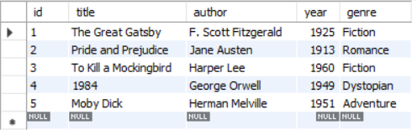

* 1. select * from books where title like "%T%";

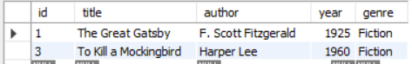

* 1. select * from books where author like "%son%";



* 1. select * from books where title like "%and%";



* 1. select * from books where title like "%bird%";

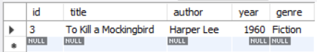

* 1. select * from books where title REGEXP '3 characters';



* 1. SELECT * FROM books WHERE title REGEXP '[0-9]';

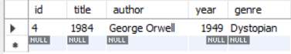

* 1. SELECT * FROM books WHERE author REGEXP '^[A-Ja-j]';

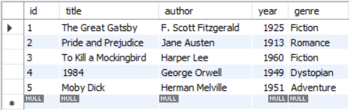

* 1. select * from books where genre REGEXP '^(Fiction|Adventure)$';

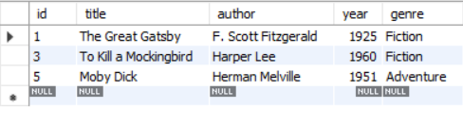

* 1. select * from books where title REGEXP '[A-Z]';

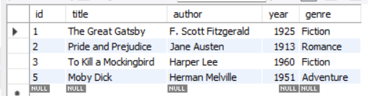

* 1. SELECT * FROM books WHERE year LIKE '18%' OR year LIKE '19[0-4]%';



* 1. SELECT * FROM books WHERE author REGEXP '^[A-Za-z]+ [A-Za-z]+$';

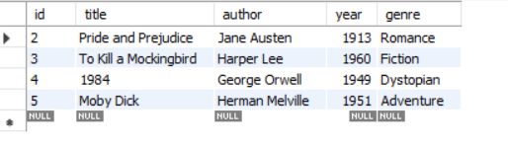

* 1. SELECT * FROM books WHERE title REGEXP '^P[A-Za-z]+$';

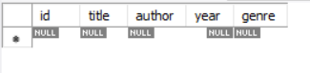

* 1. SELECT * FROM books WHERE title REGEXP '^[A-Za-z0-9]';

